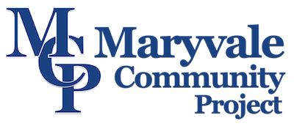



Hospitality

Role Description

Location: Kingstanding, Birmingham

Purpose of role:

Maryvale Community Project (MCP) is based in Kingstanding in the North of Birmingham since 2004. In response to a lack of support for older people in the local area we registered as a charity in 2011 and have continued to support older people by facilitating a telephone befriending service for the over 55’s to combat feelings of social isolation and loneliness.

The lunch club runs every Tuesday between 12:30-2:30 pm and provides a safe, warm, and friendly space where older people can meet and enjoy a two-course healthy meal along with light exercise, group games and musical entrainment. Hospitality volunteers are needed to be available Tuesdays between the hours of 11am –3pm.

As a Volunteer you will:

- Support and help our members to feel welcome.
- Assist in preparing food and drinks.
- Set up the room layout.
- Lay the tables.
- Support members with mobility issues to participate in activities.
- Assist with clearing away (tables and activities).
- Assist with kitchen duties.

In return we provide:

- Appropriate induction, training, and support from MCP’s Communities Outreach and Activities Coordinator and any other project staff.
- Meet new people and work in a friendly supportive environment.
- Agreed out-of-pocket expenses.
- Valuable experience of volunteering that you can add to your CV.

Skills and experience required:

- Understanding of working with older people.
- Active listening skills.
- Patience.
- Some sensitivity to issues relating to vulnerable older people.
- Ability to work within a volunteer team and to take instruction from staff.
- Ability to respond calmly but quickly in an emergency.
- A willingness to have fun.
- A willingness to participate in activities.

Time commitment?

Hospitality volunteers are needed to be available Tuesdays between the hours of 11am –3pm. Although we do value the time you are willing to give us and will work with you to find a mutually agreed time.

For more information and to apply for this role please contact
info@maryvale.co.uk
01213823590
Reaching out to provide social care in the Catholic Archdiocese of Birmingham
Registered in England and Wales no. 1653388.
Registered charity no. 512992.
Father Hudson’s Care is a working name of Father Hudson’s Society.

www.fatherhudsons.org.uk | enquiries@fatherhudsons.org.uk | 01675 434000

