

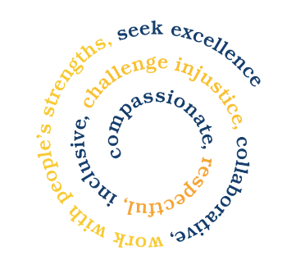

Social Group Volunteers
(No previous experience required, full training and support will be provided)

Role Description

Location: Newcastle Under Lyme & Stoke on Trent

Purpose of roles:

Father Hudson’s Care, The Young at Heart Project provides support and activities for older people who may be experiencing social isolation and loneliness, also, they may be living with dementia, mental health, and physical disabilities.

Not all our members have family or friends who can visit them regularly, however, it is important that they feel part of the local community and the wider world. Our project helps to bridge that gap by bringing older people together to socialise with other members within their local community whilst providing them with activities and refreshments.

As a Volunteer you will:

- To assist in the smooth running of the group.
- The setting up and the taking down of tables and chairs.
- Willing to shop and serve refreshments to the group members.
- To assist in washing up as required.
- Ensuring good hygiene standards are always maintained and to carry out cleaning as required.
- To assist members with filling in registration forms and other necessary paperwork.
- Be registered with Father Hudson’s volunteering scheme.
- Respect and value service users’ knowledge, experiences, and opinions.
- Adhere to Safeguarding, Confidentiality, Health and Safety and other relevant policies.
- Participate in role related trainings, meetings, and events.

In return we provide:

- Appropriate induction and role related trainings.
- Valuable experience of volunteering to enhance your CV.
- Opportunities to make a real difference to someone’s life in your community.
- Payment of agreed out-of-pocket expenses.
- Regular support, advice, and guidance.
- Invitations to staff and volunteer events such as: Volunteer Network Meetings where you can meet other volunteers, share experiences, and contribute to the development of our volunteering services.
- Work reference.

Skills and experience required:

- To be friendly, approachable, and committed to the role.
- Reliable, patient, and sensitive.
- Understanding and empathic about the needs of service users.
- Flexible in approach to the role.
- Good communication skills and sense of humour.
- Recording and reporting information.

Do I have to be Catholic to volunteer for Father Hudson’s Care?

No. We trust you to share our values of Equal Opportunities and respecting every individual, treating people with respect, dignity, and kindness.

Time commitment?

3 hours per month, ideally for more than six months. However, we value the time you are willing to give us and will work with you to find a mutually agreed time.

For more information and to apply for this role please contact
Alex Baines Project Coordinator
Alexandrabaines@fatherhudsons.org.uk
Call 07467 062139

www.fatherhudsons.org.uk | enquiries@fatherhudsons.org.uk | 01675 434000
Reaching out to provide social care in the Catholic Archdiocese of Birmingham
Registered in England and Wales no. 1653388.
Registered charity no. 512992.
Father Hudson’s Care is a working name of Father Hudson’s Society.

